Semi-Report

Charlie Nitschelm  
11/12/19  
Modern Physics  
Experiment 2

# Problem 9 – Historical Notes

It was noticed when analyzing different element gases that each of them emit different wavelength-intensity charts. Using a spectroscope, scientists of the time started to notice that each element when excited by a voltage differential would light up and emit a different color, and, a different spectrum of light. Below is a figure of the elements that were first looked at for this phenomenon.

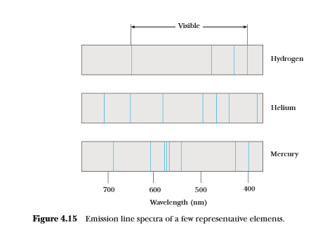

Figure - Initial spectral lines for common elements tested during the early development of using spectral lines to classify the elements

The scientific community quickly noticed that each element had a unique spectrum of lines that were more pronounced on certain wavelengths. This tool was then tested in more configuration to see what could affect this outcome of elements, including the combination of multiple elements at once. Kirchhoff below was a scientist who lead this analysis and found new, clever ways to experiment on this phenomenon.

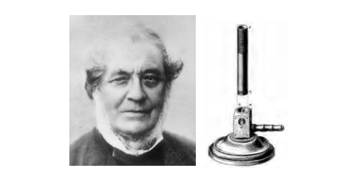

Figure - Robert Willian Von Bunsen who developed the first scientific analysis of the spectral lines obtained from different elements, with the accompanying more-famous invention of the Bunsen burner.

He also was the scientist to test how vapor of a different element/compound would affect the overall spectral line of the sun using the device below.

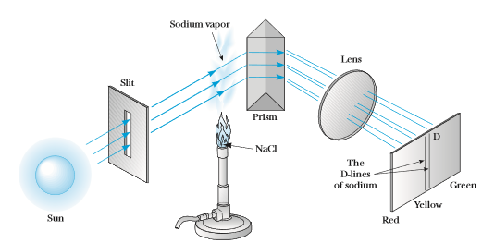

Figure - Kirchhoff’s experiment testing how the conflict of other gases have on the overall spectral series, showing darkening and brightening of certain lines with the introduction of different gases

The experiment also played on the affect of how the temperature of the element can affect the relation between what is emitted and absorbed in terms of its overall spectral series lines. These tests quickly created a way to identify elements of light from around the solar system, galaxy and universe and continues to be an important tool in modern science.

# Problem 10 – Theoretical Background

Observing excited element gases that were emitting light, like a gas tube lamp, excited the individual atoms and emit a certain combined color dictated by its elemental composition of atom structure. The physical mechanisms involved with a gas tube lamp are the attachment of electrical leads that are capable of sending a discharge of current through an ionized gas and the free electrons are accelerated by the field in the tube and collide with the gas and metal atoms, causing light emission. When viewing, a diffraction grating separates the light waves into spectra. It does this by diffracting the light at various angles from the addition of constant, very small grooves in the grate. The overall analysis of the observed affects is governed by the equation



Where n is the order of diffraction, lambda is the diffracted wavelength, d is the grating constant, which is the distance between successive grading grooves, and $θ_{i} and θ_{d}$ are the angle of incident measured from the normal line and the angle of diffraction measured from the normal, respectively.